- \Operation\Laminar flow device\Settings
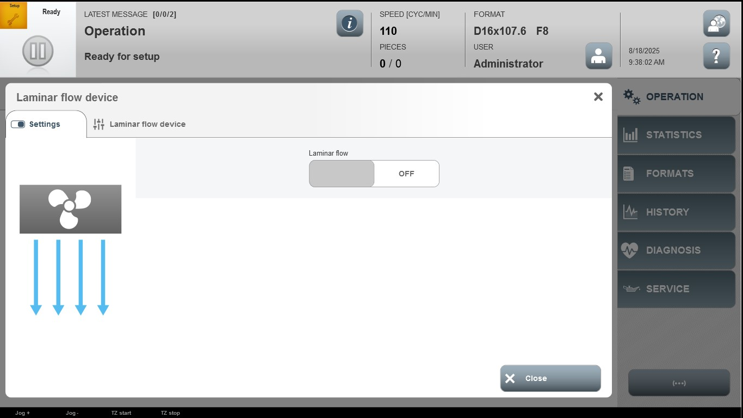

Acceptance criterion | Limits | Pass / Fail: Dev-No. | Date | Initials

